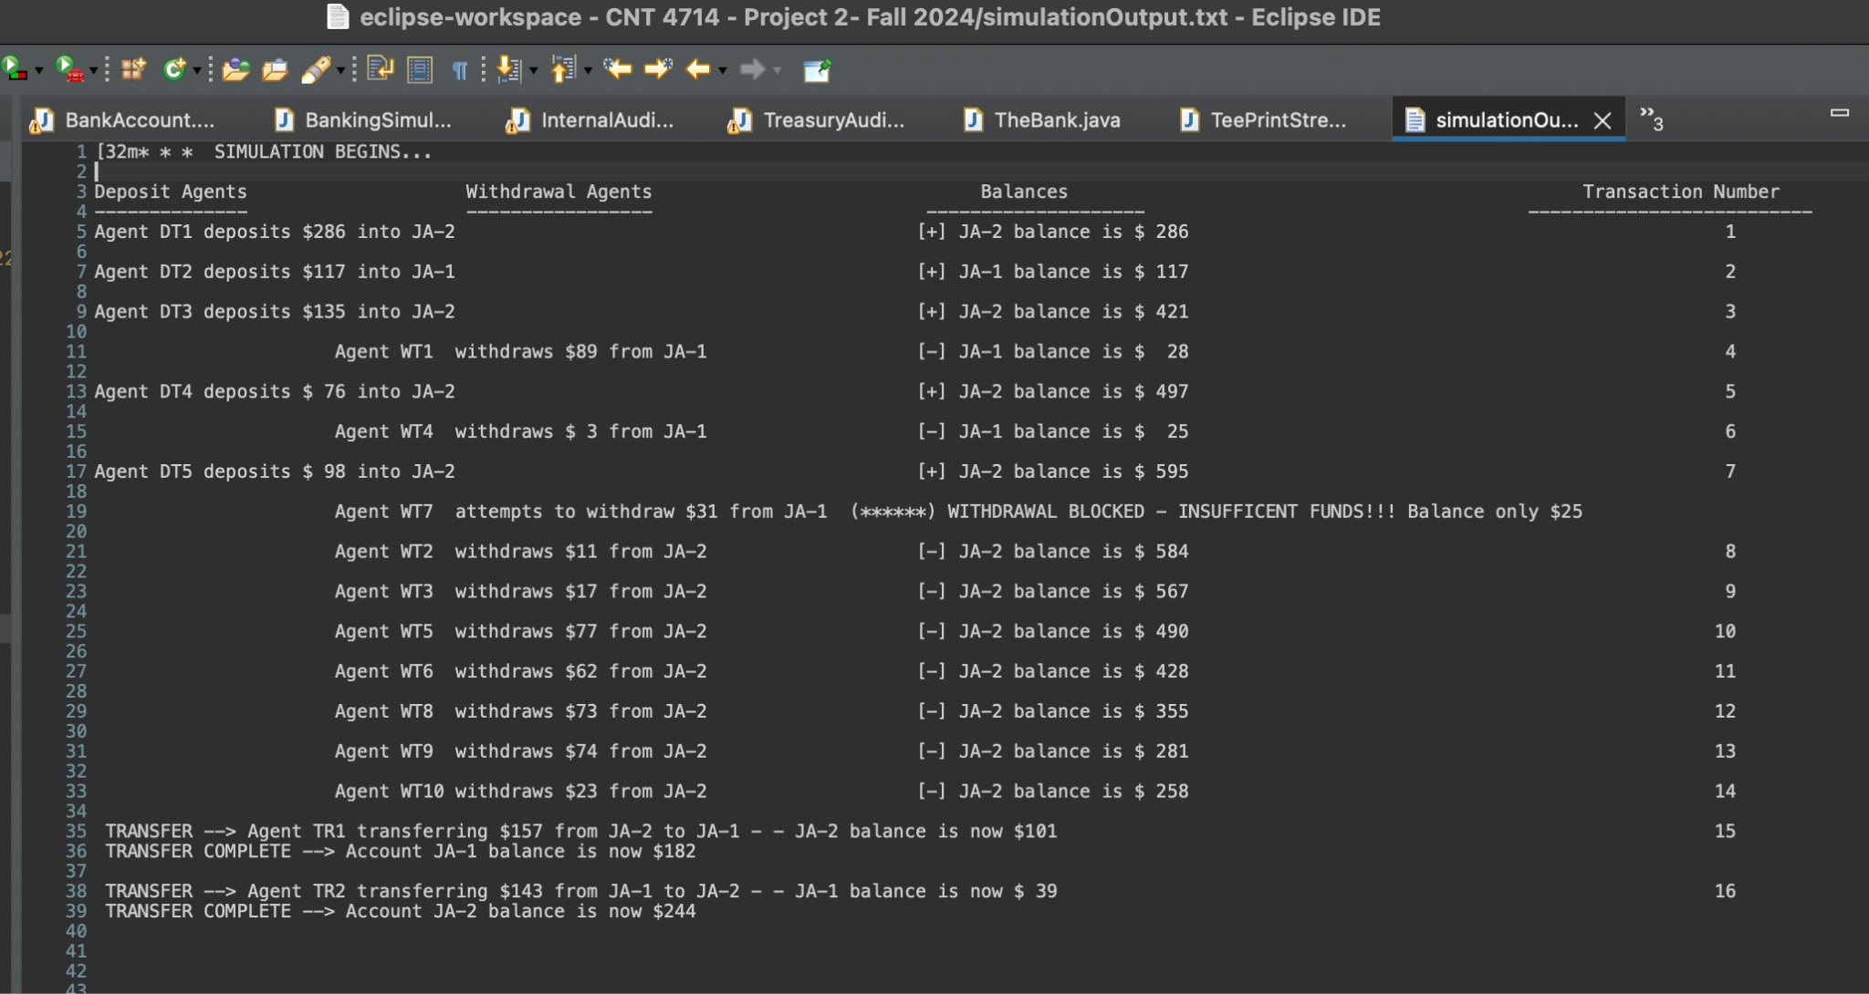

Screenshot 1: Displays first 16 transactions. Deposit, Withdrawal, and Transfer agents have initiated, begun running, and successfully completed the transaction. Also, when there are insufficient funds in an account, it won't perform a withdrawal.

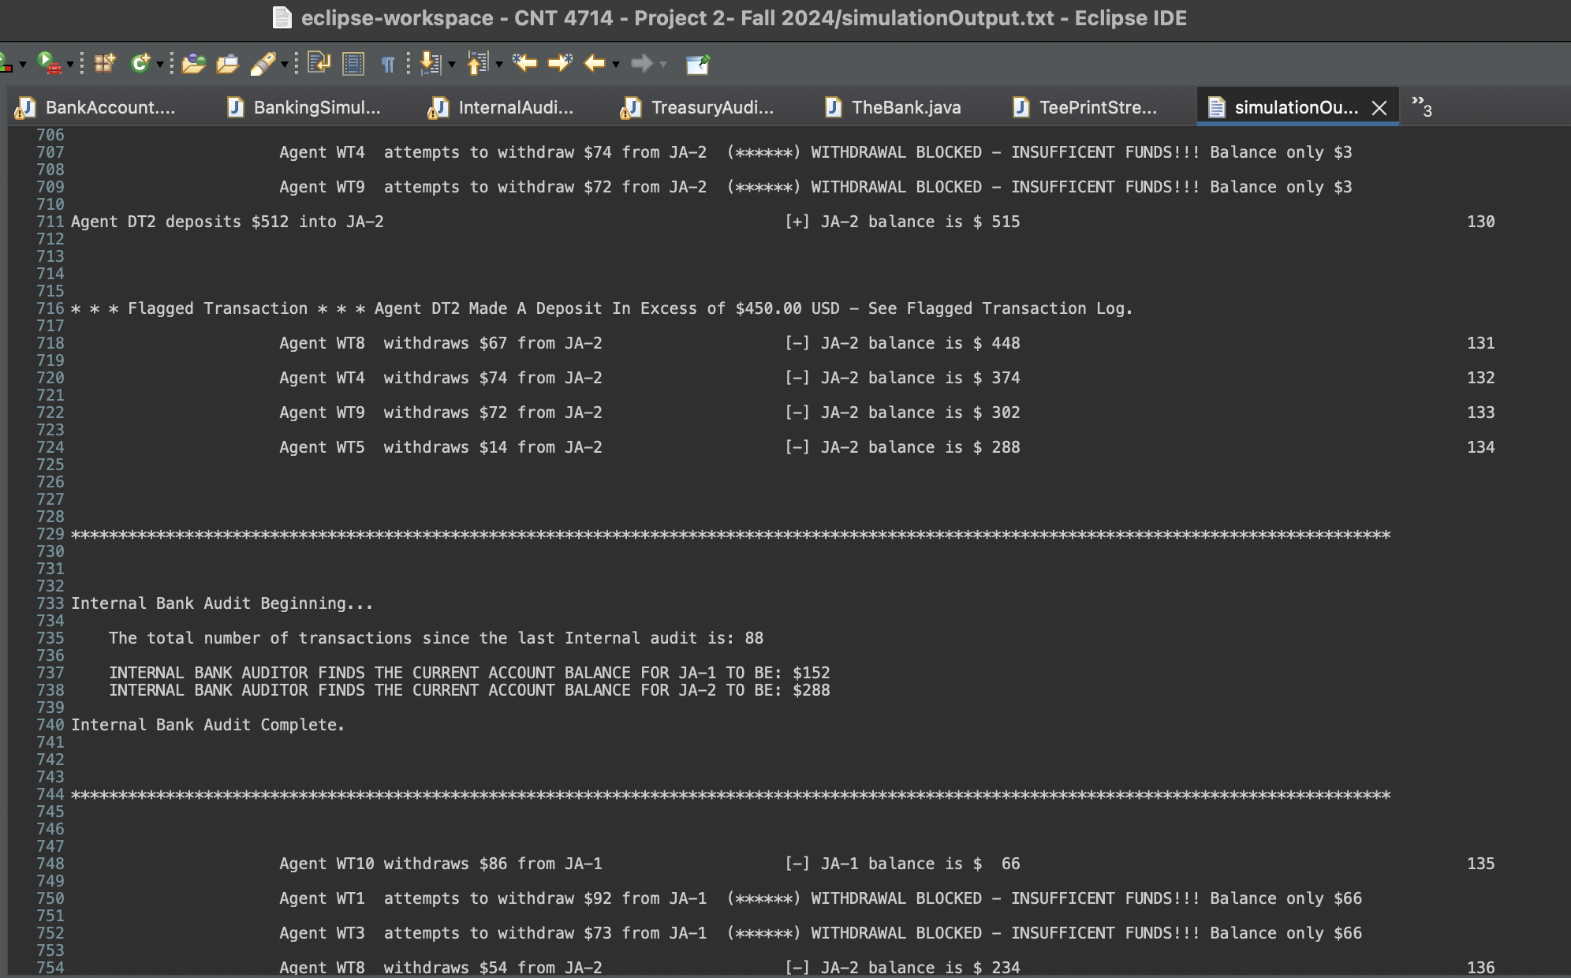

Screenshot 2: Internal Audit agent is run and calculates the number of transactions since the last internal audit. Accurately reflects the balances in both joint accounts. It is not related to the Treasury Department and shows different balances than the Treasury Department Audit

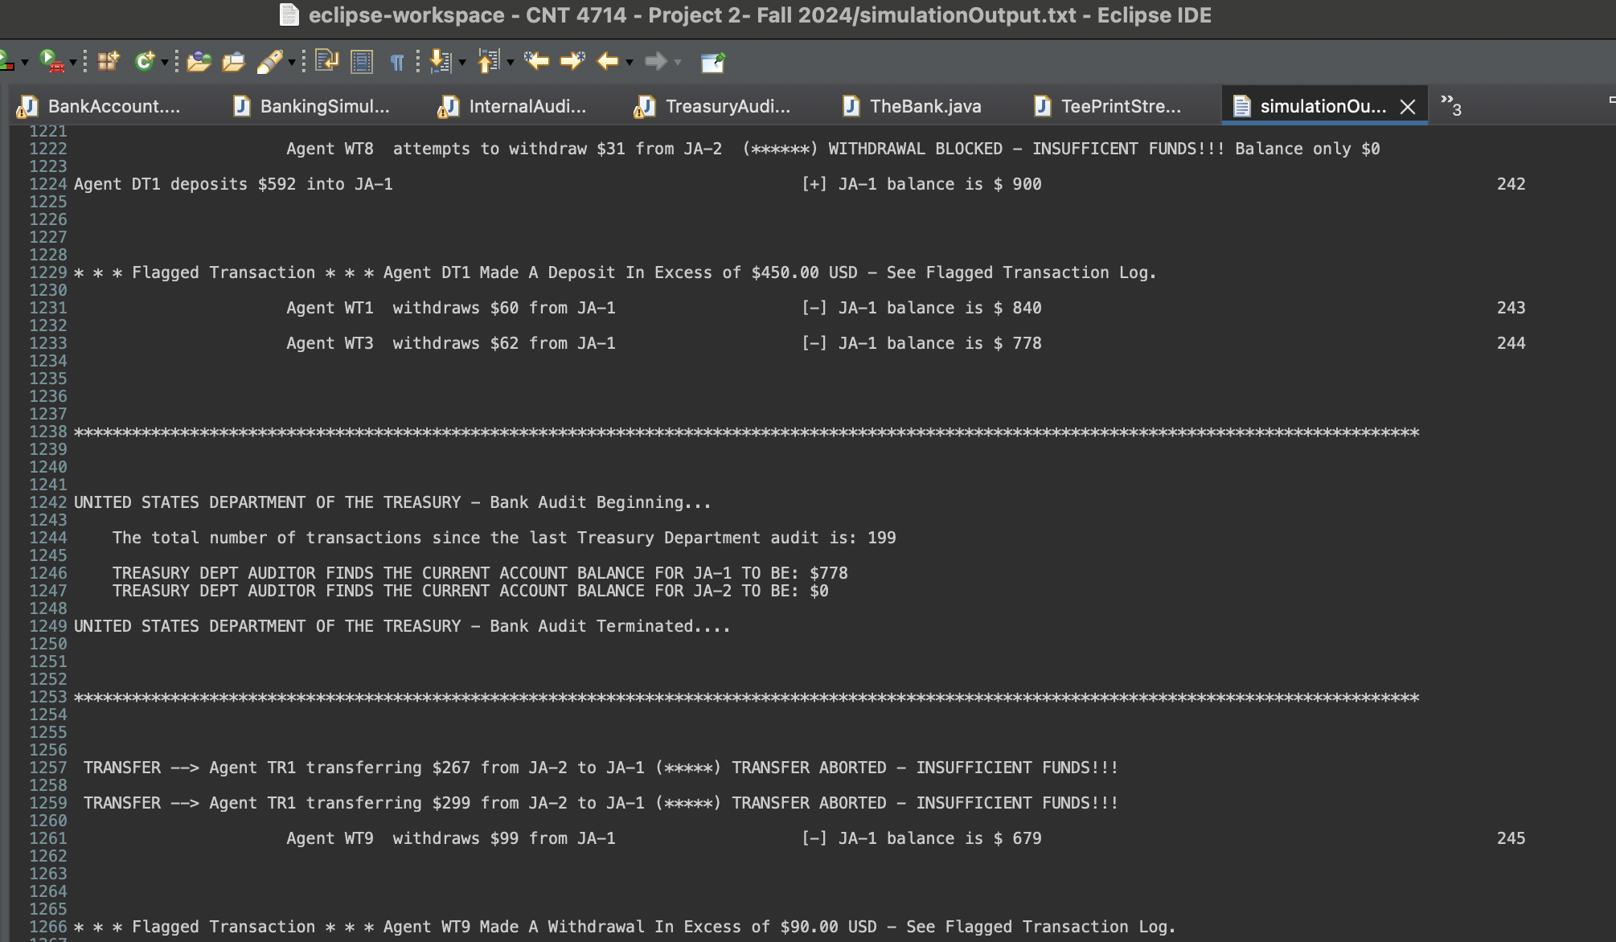

Screenshot 3: Department of Treasury agent is run and calculates the number of transactions since the last internal audit. It accurately reflects the balances in both joint accounts. It is not related to the Internal Audit and shows different balances than Internal Audit.

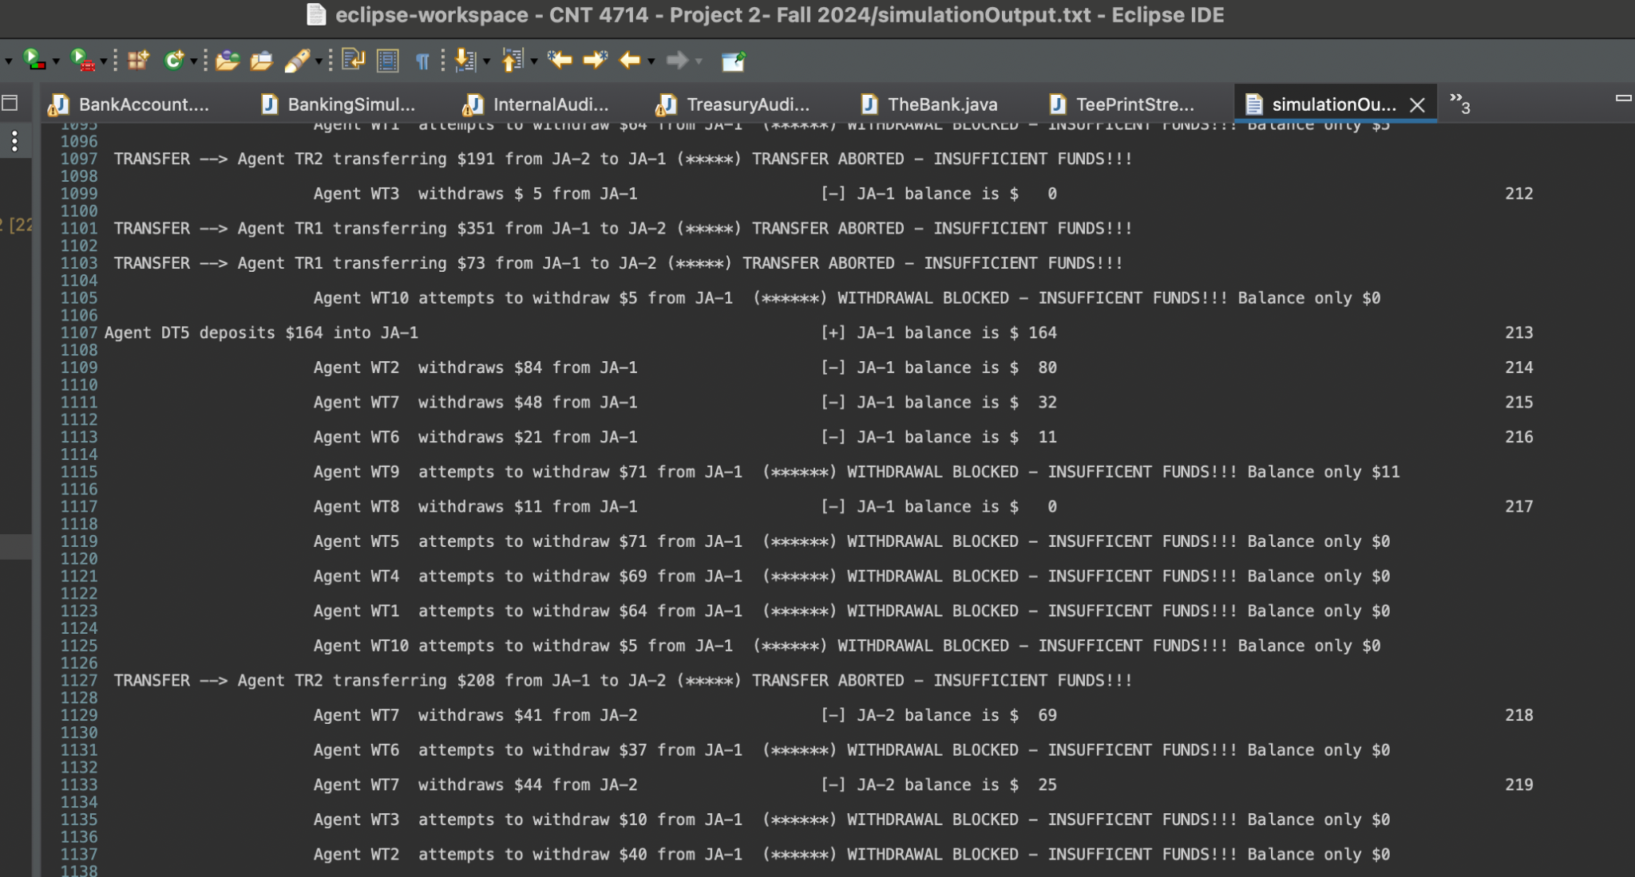

Screenshot 4: All withdrawal agents were blocked because there were insufficient funds in the joint accounts.

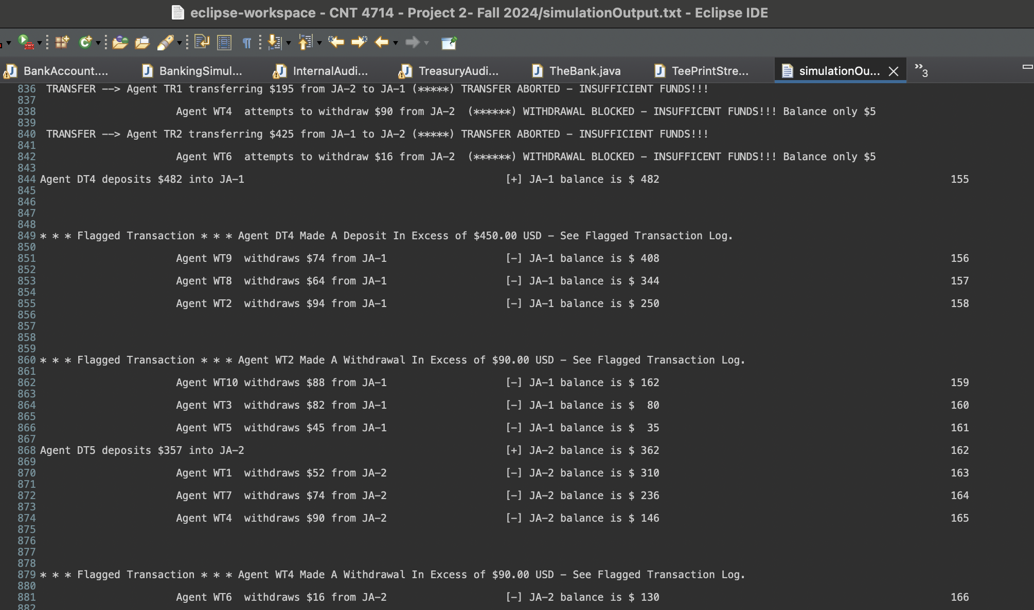

Screenshot 5: Transaction amounts made have exceeded the alert level set in place, indicating the transactions(deposit and withdrawal) to be flagged. (Numbers 155, 158, and 165)

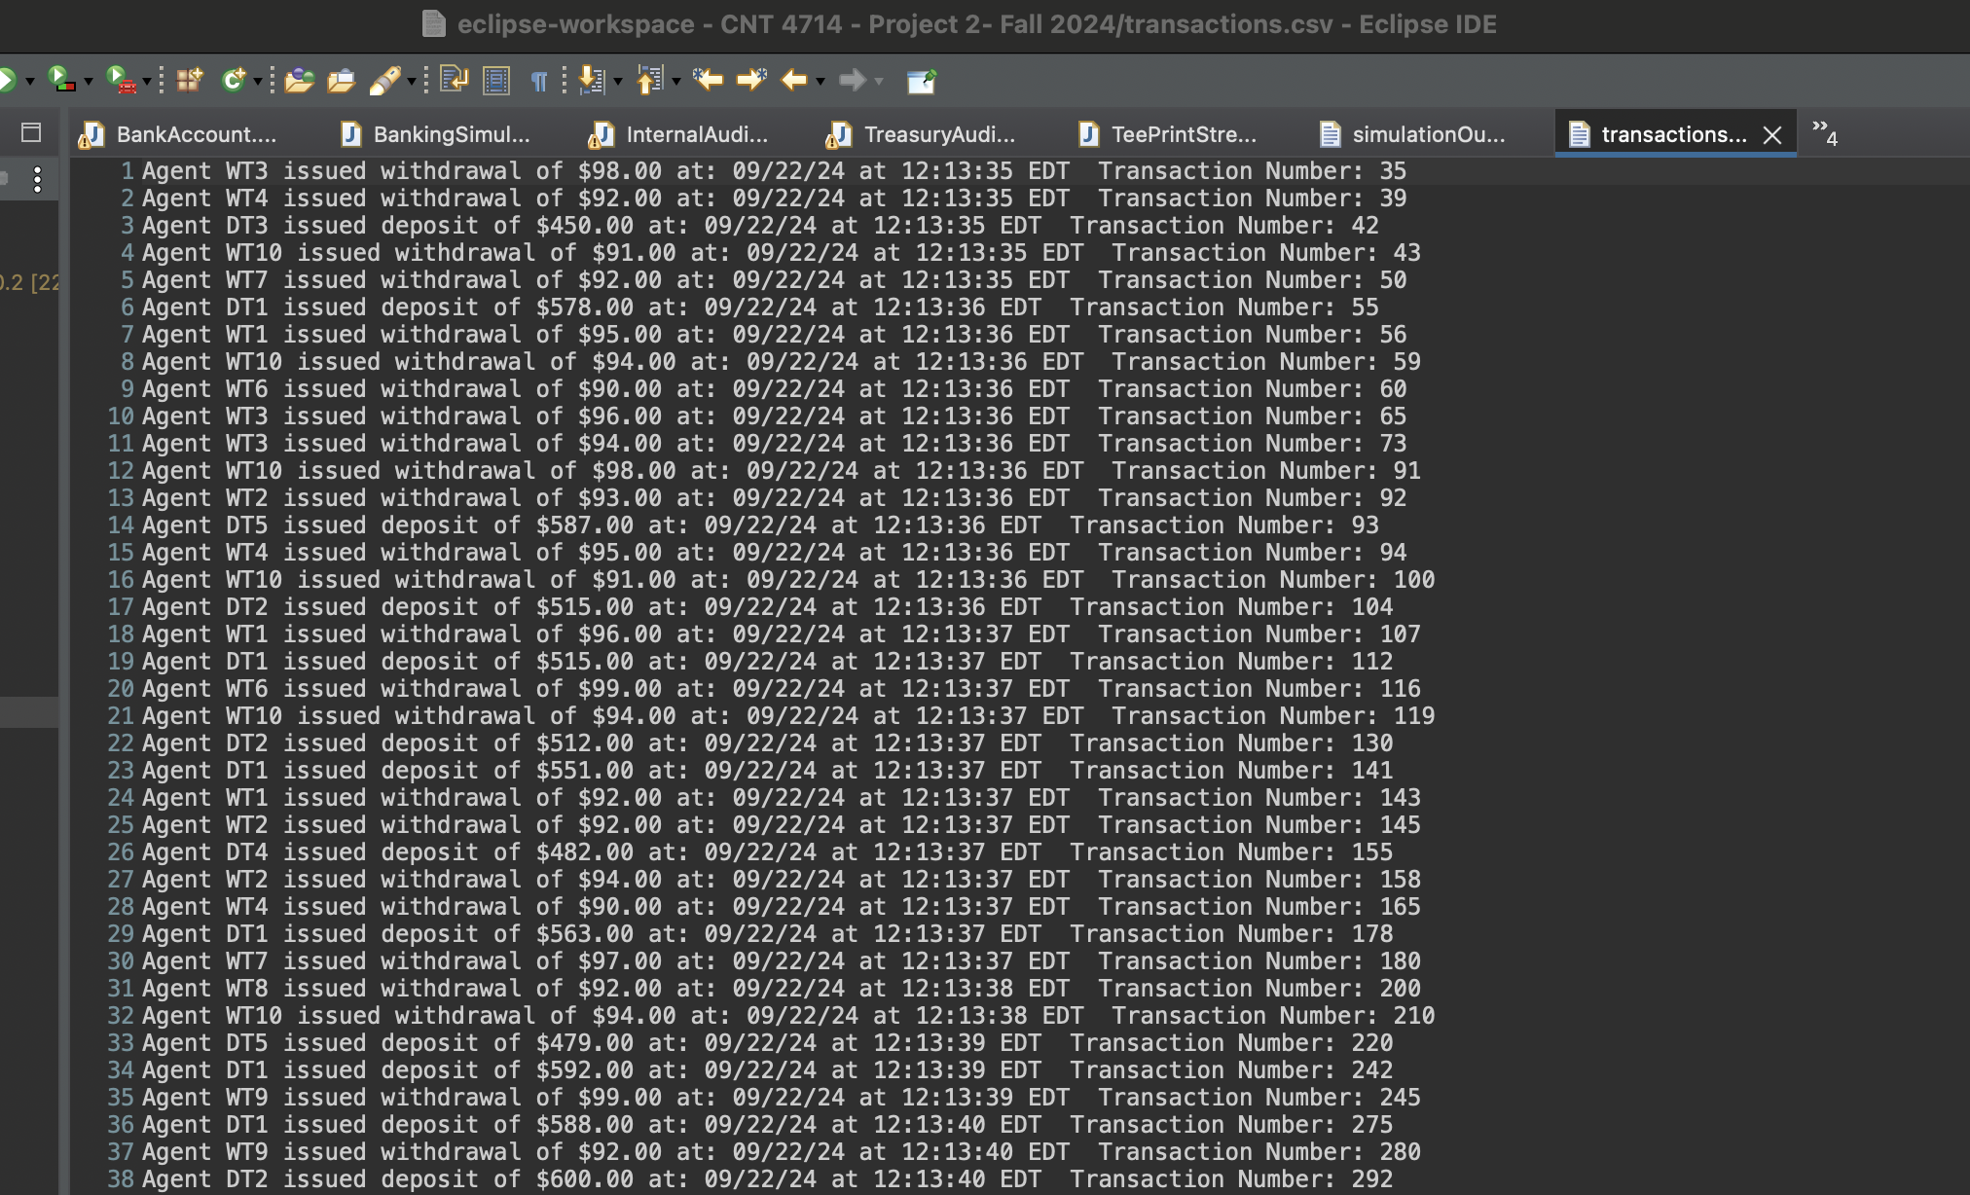

Screenshot 6: Notice the transaction numbers that are being marked as flagged are accurately displayed in the transactions.csv file from the screenshot above. (Ex: 155, 158, 165)

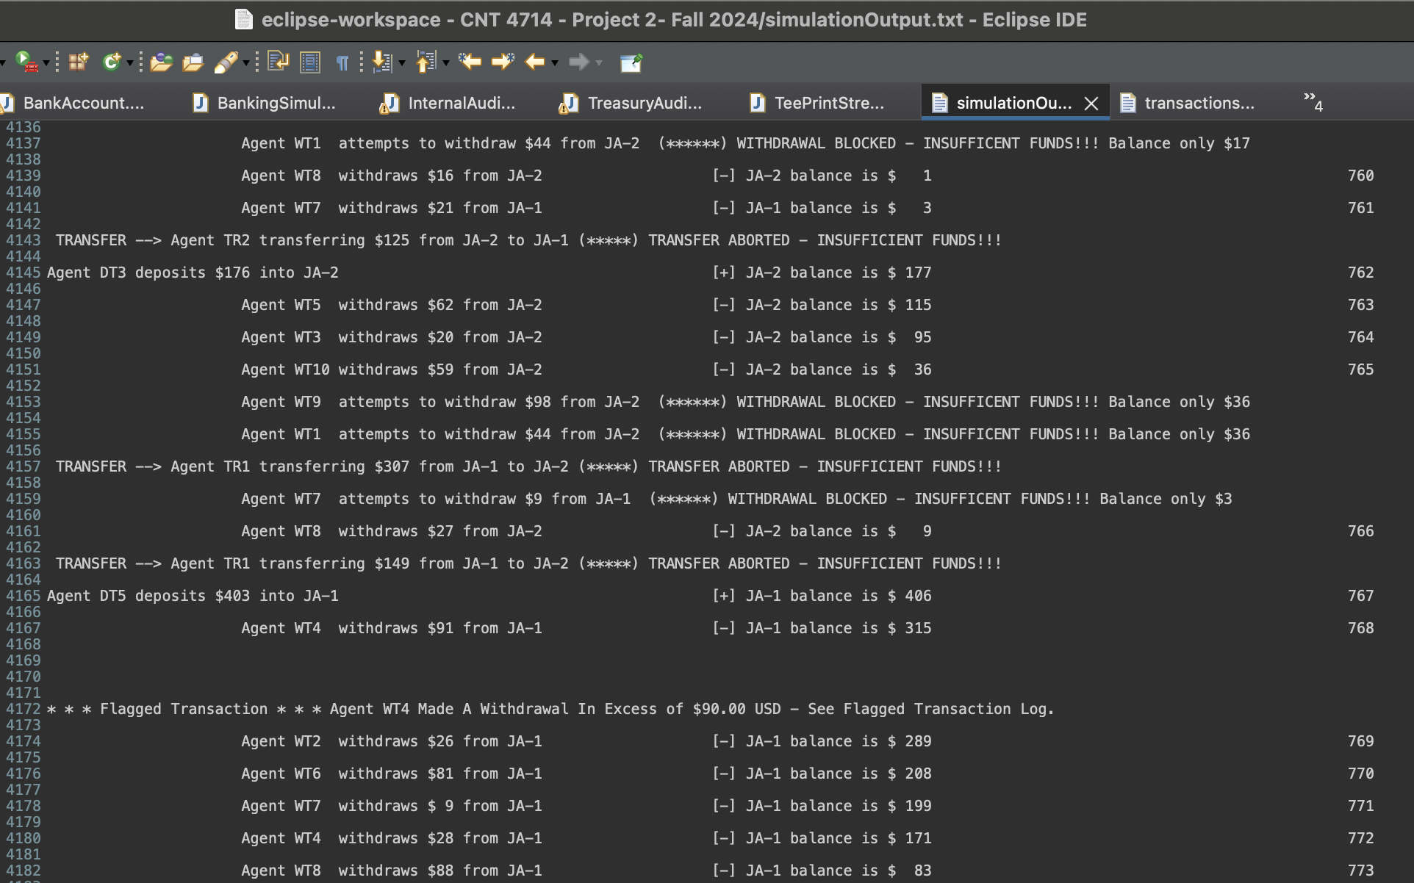

Screenshot 8: Synchronized threaded application ends at transaction number 773, notice the JA-1 balance is $83 and the JA-2 balance is at $9. This indicates balances are not accumulating overtime and the deposit agents are sleeping enough as intended.